**IT5503**

**A GRAFF**

**2231290**

**A1 Math for Kiwis**

**Debugging**

**Debugging the if statement (for user input to see if matching total indicating correct answer) Expecting the answers to match.**

**We can see Total value and playertry input matches in the bottom left corner.**

**Debugging a correct user input answer.**

**We can see playertry input answer is correct by correct answer points 1, an image showing green tick and an answer behind question mark label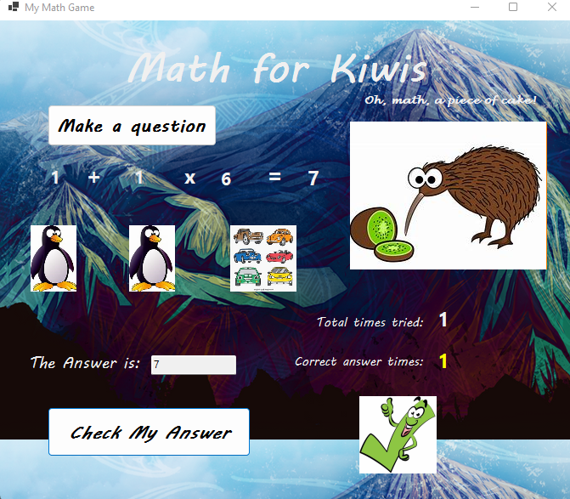 as expected.**

**Debugging testing the player incorrect input answer. Total answer is 29 and user input is 40 which does not match as expected shown in Debug Output.**

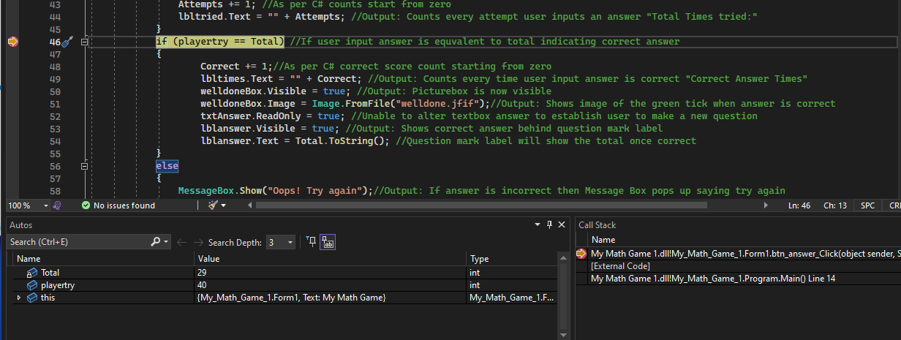

**Incorrect debugging testing of Math Game – you can see “oops” message box pop up, and the total times tried 1 and 0 on the correct answer times as expected.**

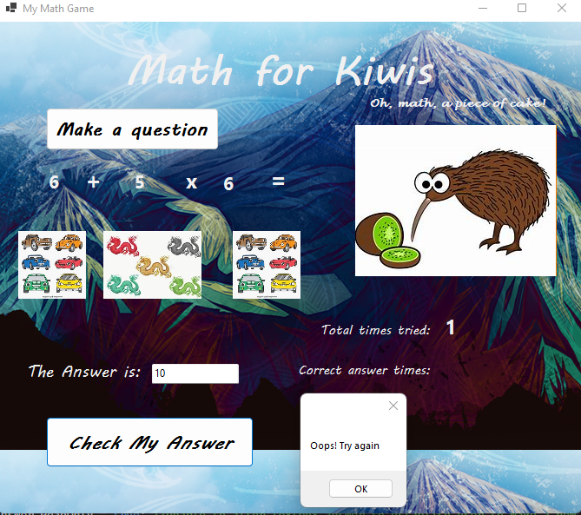

**Flowchart Visualisation**

